**How to create EC2’s and Security Groups using AWS CLI in Windows**

**9.2.19**

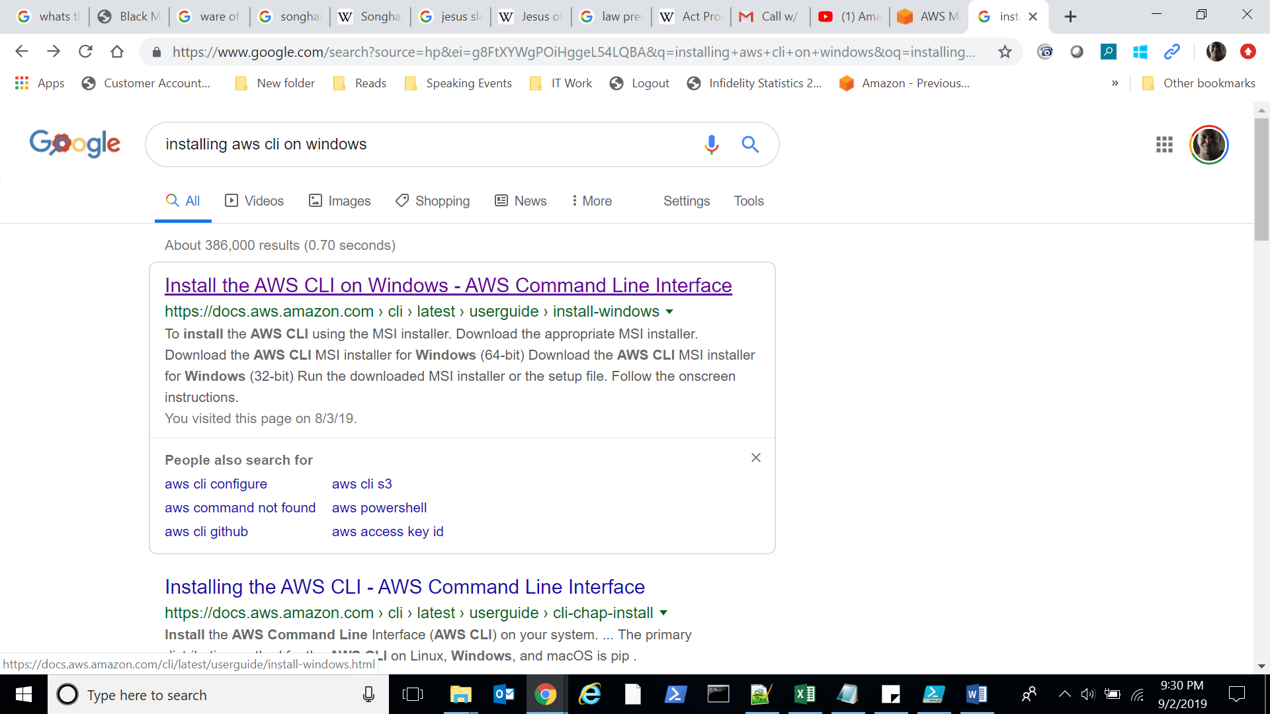

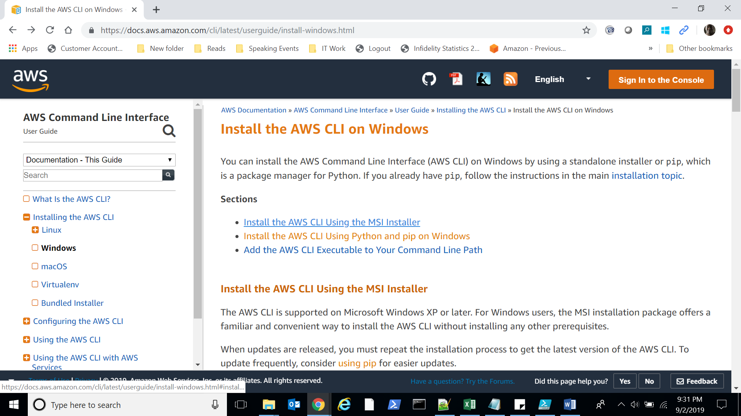

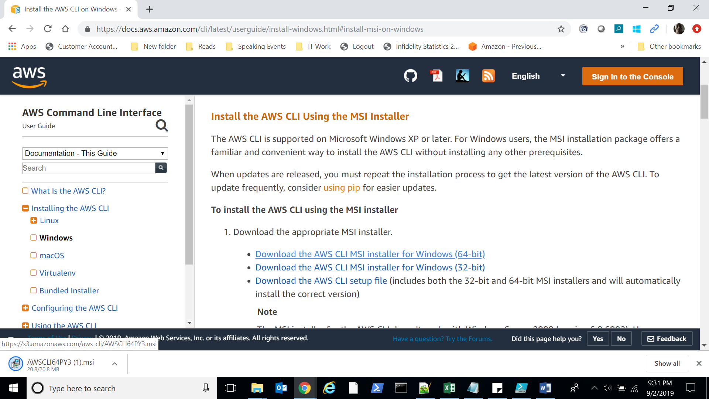

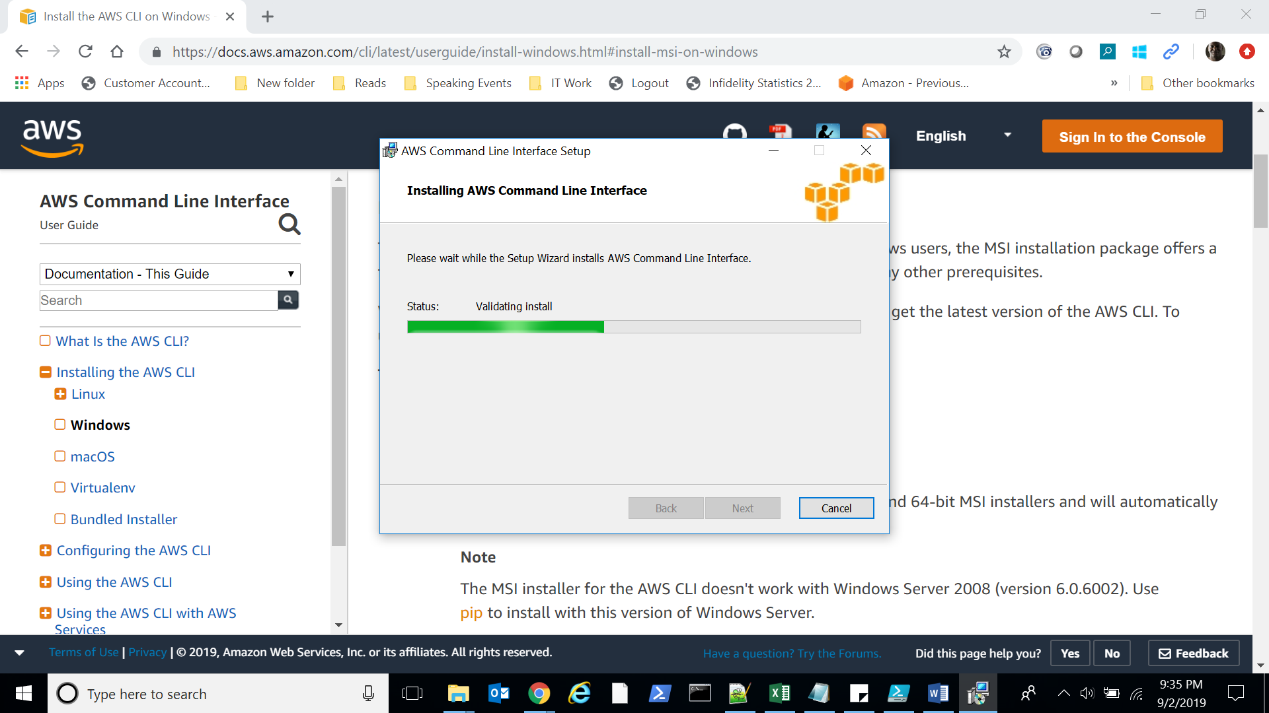

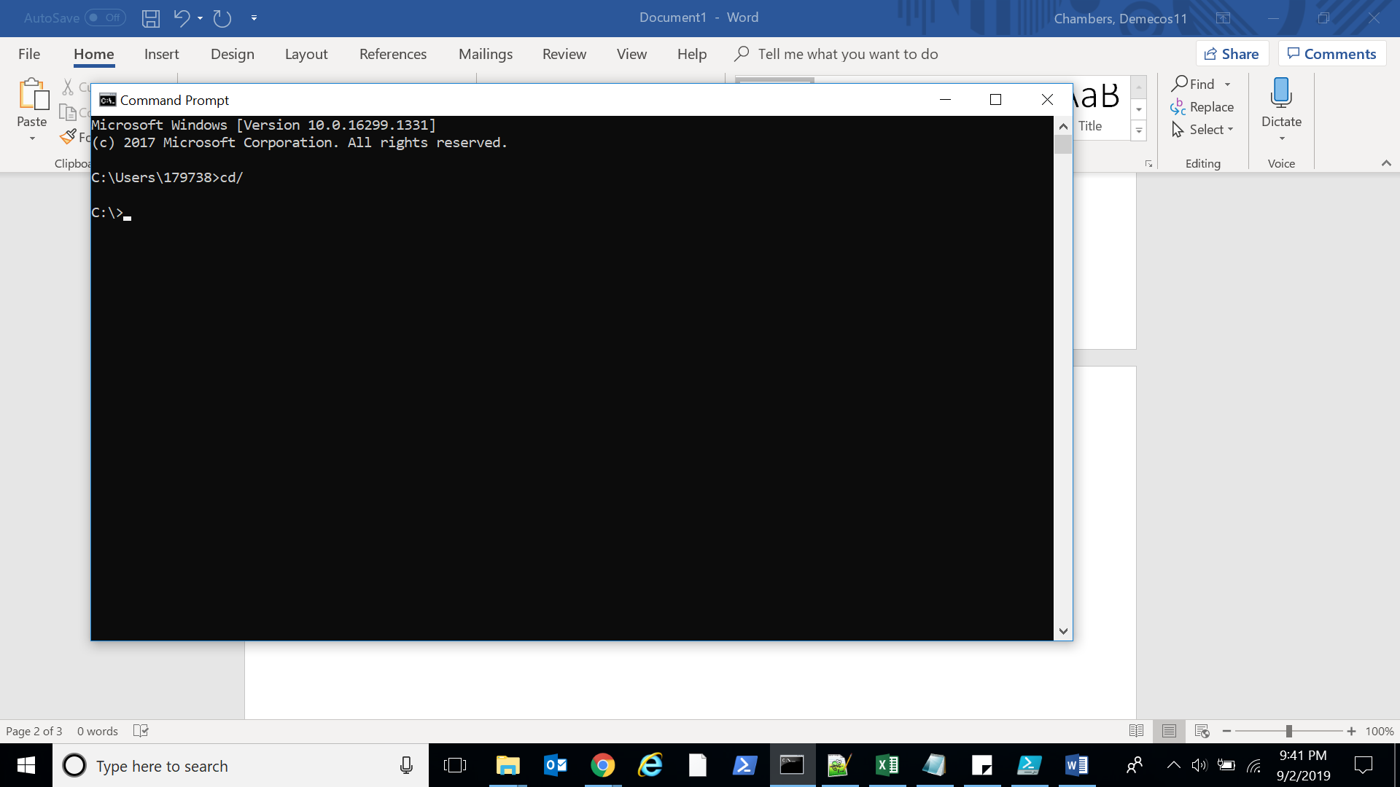

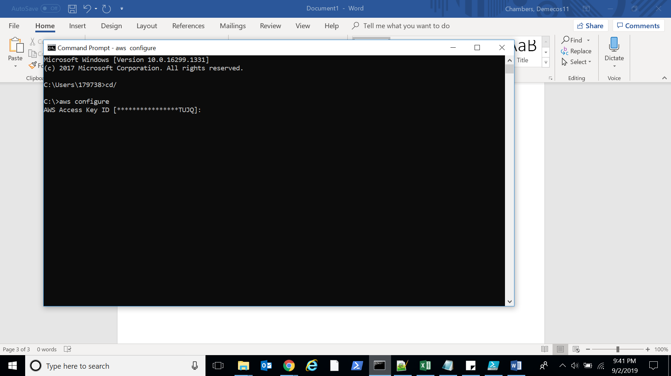

Download the Security Credential file under your username tab in AWS.   
I’ve already saved mine.

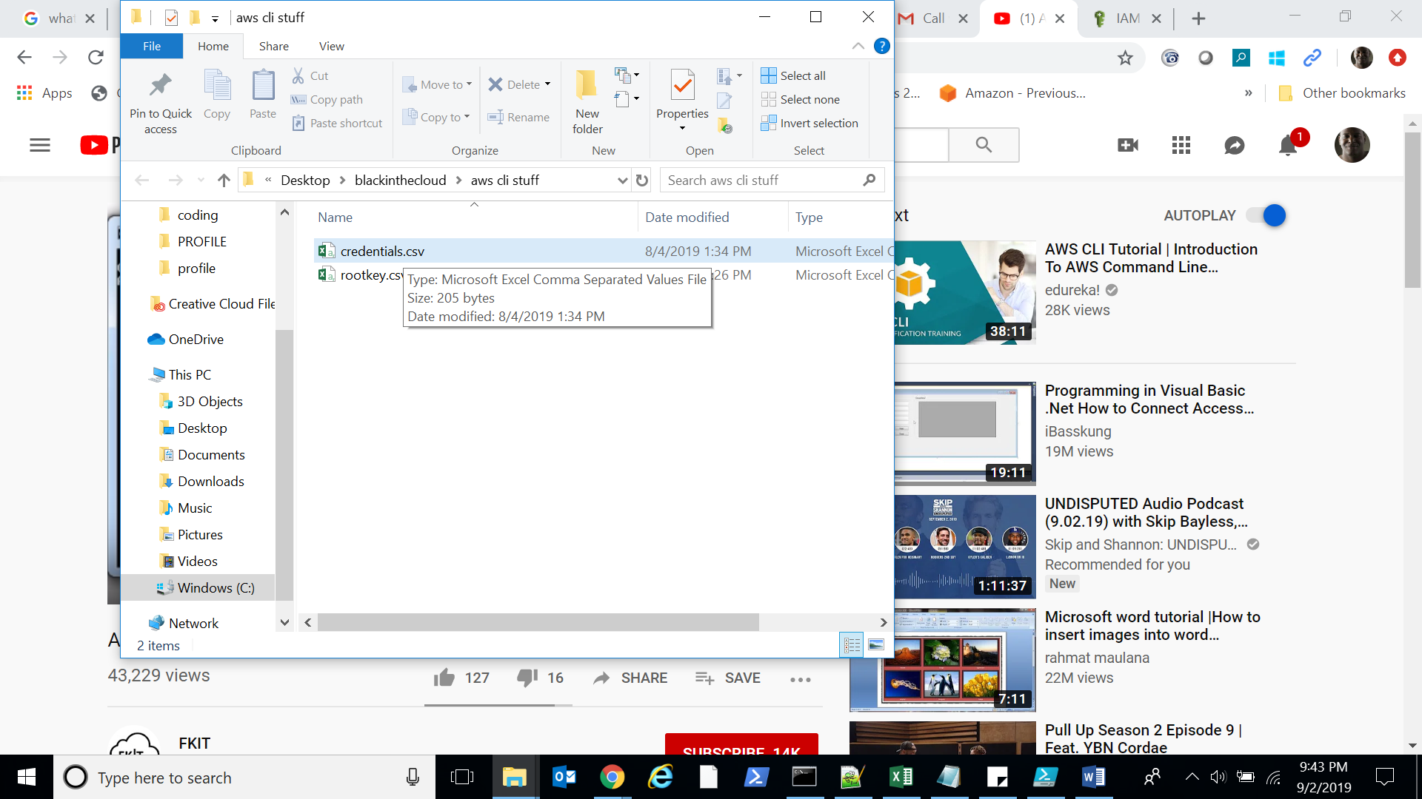

User your credentials to enter into the command lines.

Enter the region you’ll be using

Enter the output format you prefer (leave at none for default)

Then boom you’re now in your aws cli and can do everything you are allowed under your permissions